

CyPERS
Design Document v1.0



Authored by:
Ignis Technology Solutions Private Ltd.

Information contained in this document is classified Ignis Technology Solution Private Ltd... Confidential Proprietary. Only authorized Ignis Technology Solutions Private Ltd. personnel shall have access to the information contained in this document unless business needs dictate, otherwise. It is the responsibility of the person knowing the information contained in this document to ensure confidentiality of information contained in it and securing this document from unauthorized access at all times.
DOCUMENT INFORMATION
Author | Ganesh Rajasekaran
Reviewer | Ajay Agrawal
Approver
Approved Date

CHANGE HISTORY
Version # | Release Date | Sections Changed | Author | Change Description
0.1 | June 18, 2010 | All | Ganesh Rajasekaran | Draft Version

TABLE OF CONTENTS
1 Introduction 3
1.1. Purpose 3
1.2. Overview 3
2 Architectural Goals and Strategies 4
2.1. Deployable Modules 4
2.2. Different Input 5
2.3. Medication HIT Ranking 5
2.4. Legacy Integration 6
3 Architecture Diagram 7
3.1. Architecturally Significant Design Packages 7
4 Deployment View 8
4.1. Software as Service 8
4.2. Mixed Deployment model 9
4.3. Standalone Model 10
5 Implementation View 11
5.1. Diagram 11
5.2. Overview 12
5.3. Layers 12
6 Data model 12
6.1. Basic Model 12
6.2. Patient Record Model 13
6.3. Order Model 14
7 Size and Performance 15
8 Hardware requirement 15
9 Software Requirement 15

Introduction

Purpose
This document provides a comprehensive architectural overview of the system, using a number of different architectural views to depict different aspects of the system. It is intended to capture and convey the significant architectural decisions which have been made on the system.

Overview
CyPERS is a multi user and multi transactional application with Rich Internet Application (RIA) feel. The main technical challenges to address by the architecture are following,
- Work-area based on User role & responsibilities
- Different Input Mechanism (e-Pen, touch screen, table-PC etc)
- Medication HIT ranking (based on doctor, group, hospital, etc)
- “Software as Service” (SAS) based model.
- Integration with existing system / data repository.
- Automatic Patient record Work-flow.
- Emergency Alters/Notification based on Patient Record
- Data Mining for Medication, Diagnosis.

Architectural Goals and Strategies
Considering the Objective and challenges of the Application, the following goals & strategies have been identified.

Deployable Modules
The Architecture supports different implementation and deployable modules. Each deployable module has got certain roles & access rights based on the service agreement with CyPERS. This deployable module approaches adheres to the SAS standards.
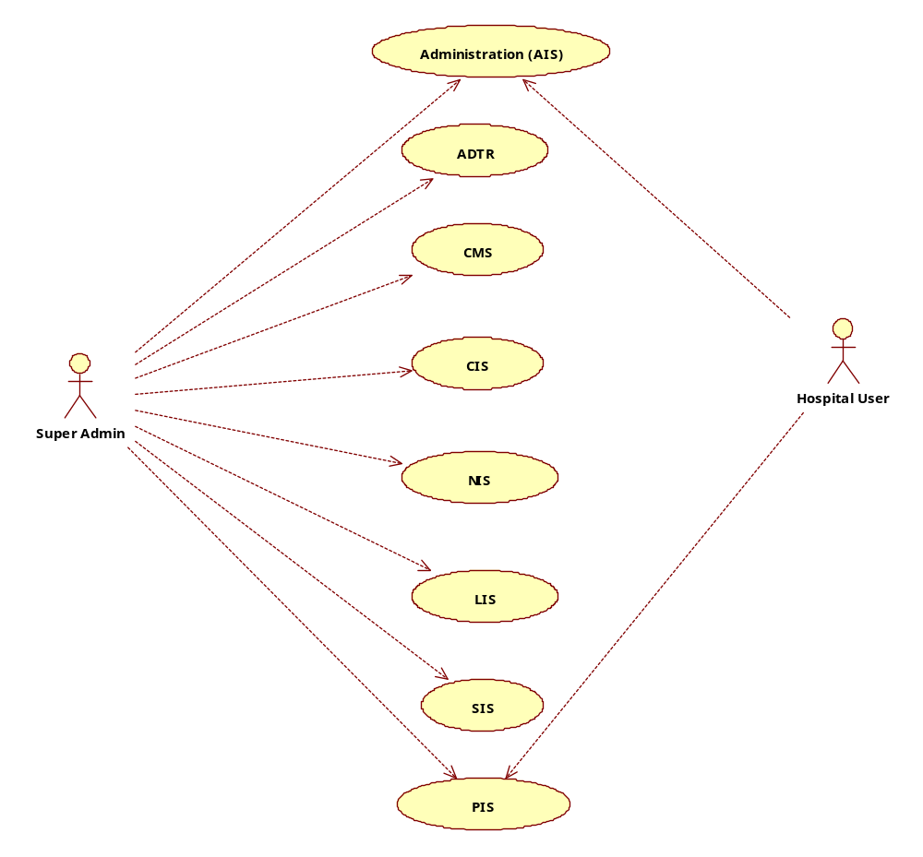

Different Input
The CyPERS should support e-Pen to capture user input. The main challenge of the different input is, the doctor can enter free text or can attach the image. The System must support different ways of input capturing for same datum. For example, in CIS Patient Record screen, the doctor can enter free text for notes or he/she can attached image (e-Pen capture). The System implements in-built knowledge to represent the data to user depends of the input captured.

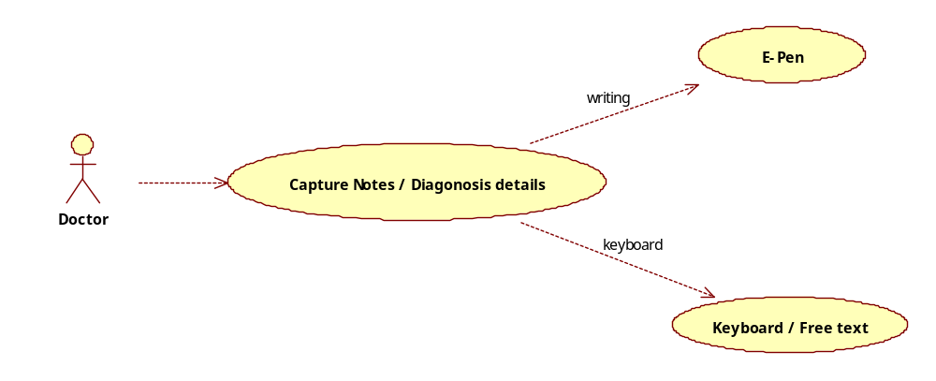

Medication HIT Ranking
This addresses the business critical challenge of the application. The System builds internal knowledge repository to capture the history of diagnosis and medication details based on the age and other criteria’s.
This Knowledge repository reduces the doctor time to diagnosis the Patient. This also ensures that the appropriate medication will be advised to a patient. Over the time, the facility improves the efficiency of the diagnosis and better data mining report.
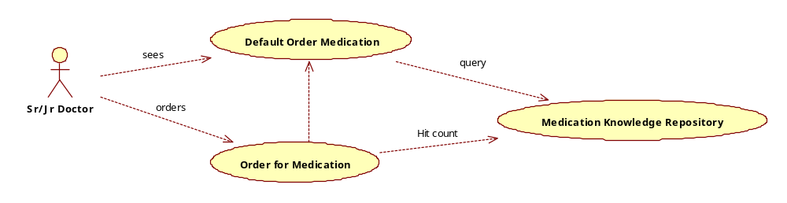

Legacy Integration
This will be very challenging technical requirement. Since the Deployment approach of the application varies from the Service to Service, we cannot go with Unified integration standard. The communication protocol differs from the System to System; we need to identify an appropriate integration approach. From the CyPERS Perspective, the System exposes the Standard way of integration points, i.e. File based approach, Web Services, Feeds etc. The entire format will be defined by the CyPERS system. To address the integration need with Legacy system, we can go with following,
- Import/Export CVS file
- Custom Web Service client implementation
- Custom Legacy code implementation.
Each approach comes with its own cost & limitations. Based on the need of User, we can suggest the approach.

Architecture Diagram

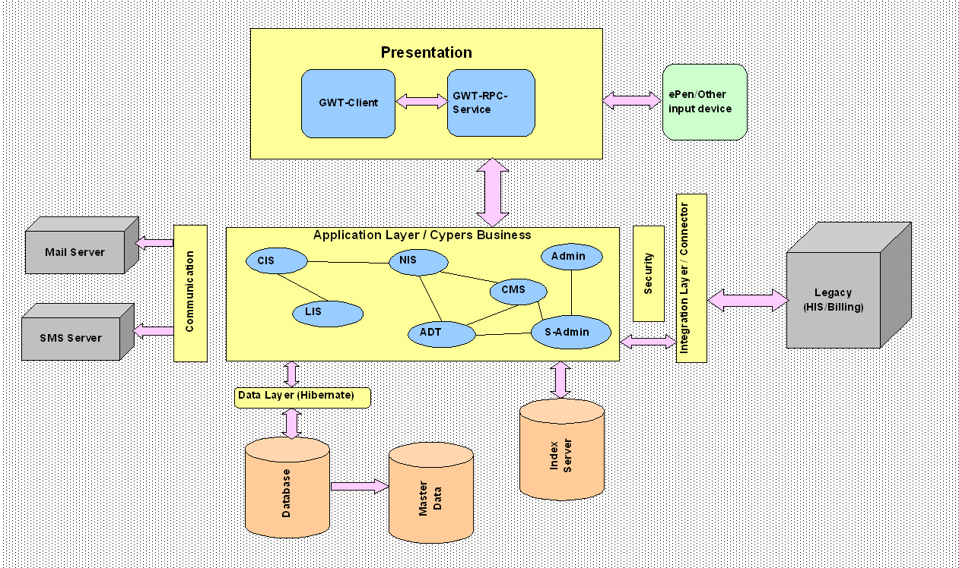

Architecturally Significant Design Packages
The System follows the Layered & deployable module Application approach. The main components are following,

Presentation Layer
Presentations Layer encapsulates the User Interface related implementations. GWT based user interface to give RIA feel. The core advantage of having GWT components are,
- Hides the complexity of the AJAX or server interaction.
- Pure Java based Programming.
- Zero JavaScript maintenance.
- Better client Side Design principles/patterns.

Application Layer
Application Layer encapsulates the business requirements of CyPERS. The Business Services are deployable at any time of the Application Lifecycle. The Services are loose coupled. Each Business Service enlists itself to a Message Bus to listen for message. At any given time, the same service can listen for different type of messages based on the type of Event generated by an Application. This ensures the dependencies of the modules are zero and unit testable in any nature. The Application Layer also encapsulates the Persistence logic within itself, the domain model never exposed public; it is restricted at Application Layer level. The intention of keeping the domain model protected to have appropriate data locking mechanism, data integrity, data consistency, HIT ranking etc.

Integration Layer
This layer exposes web services to integrate with Legacy Application to achieve ERP. As the Web Service is an industry standard for collaboration, we will publish the default data model required for the Patient Record which adheres to the Health Care Industry standard. This also supports standard JCA connector for Java application interaction, if any.

Communication Layer
Though the name of the Layer seems meaningless, it encapsulates the different external communication mechanism of the application. It is very similar to Integration Layer but not exactly. This layer addresses the requirement like e-mailing, short Messaging, internal Chatting etc. The Application Layer pushes the messages to be delivered to users. The Communication Layer decides the mode of transmission and sends the message across. It is always one way communication, i.e. only pushing to the users; it never listens for the message from the user. The scope of this Layer would be extended based on the need.

Security Layer
This Layer provides the authentication and authorization services which are global to all the Layers. Each services or features exposed by the Layers are protected and which needs to be authorized before realizing the actual service. This ensures the data protection even to read/access it for reporting. By default, every layer expects the user context to be carried across depends on mode of login.

Deployment View
The System support following deployment approaches to address the CyPERS performance criteria.

Software as Service
In this mode, the complete infrastructure is owned by the Product Owner. As the data is a legal entity, this mode addresses the data protection and will never get exposed to public. The following diagram depicts the SAS model of deployment.
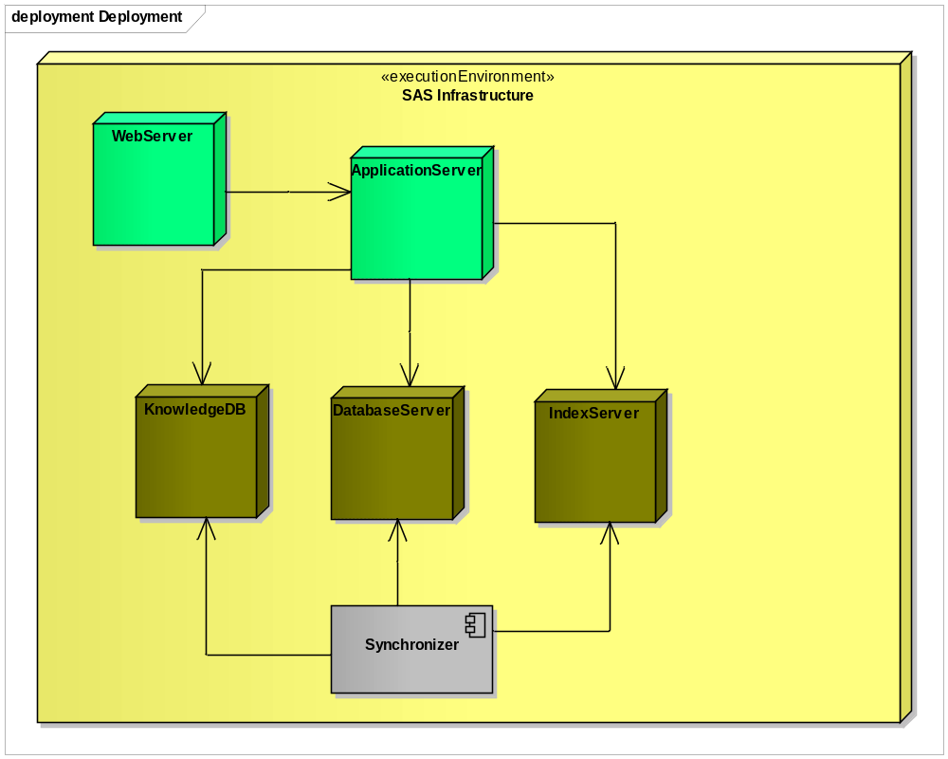

Mixed Deployment model
This mode is an extension of SAS and there will be small deployment infrastructure at client location to increase the performance of the Application. At client side, only part of the subset of data exists like knowledge Database, master entity, Image repository etc. Basically, this is Master/Slave approach. In this, a Synchronizer component keep pulls the data from the Master node to sync the local database.

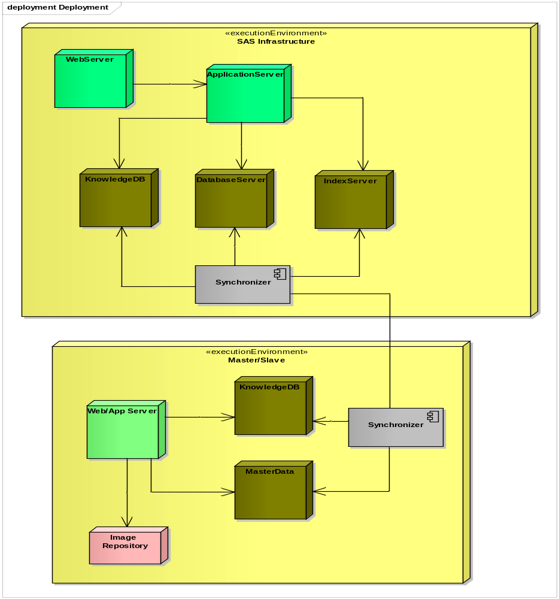

Standalone Model
It is same as the SAS model of deployment, but it is deployed in the client location. This model does not support Synchronization facility with the Master Server. It is completed disconnected model where the Master Server (SAS) and local server never interacts, so the data will not available at Central SAS System for mining etc, or internet access.

Implementation View

Diagram

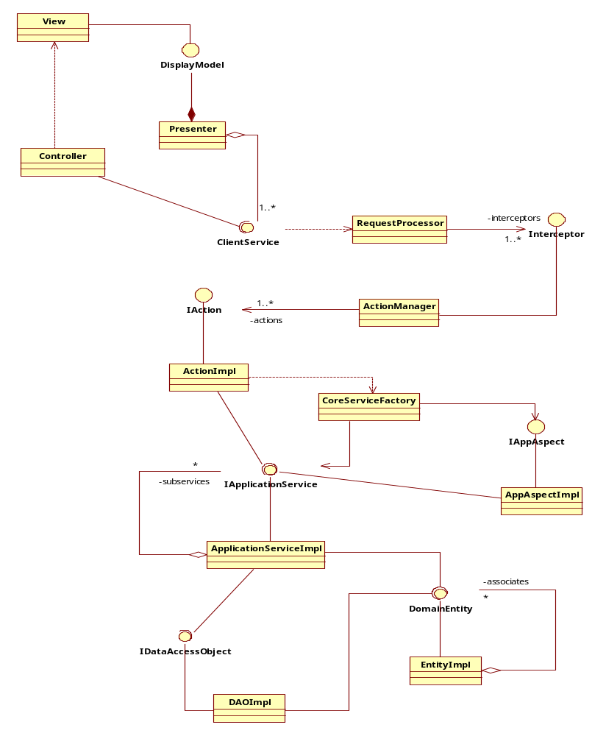

Overview
This section captures the core technical details of the Application. It is intended that the reader must have the java knowledge to understand in detail.

Layers

Presentation Layer
TODO

Delegate Layer
TODO

Service Layer
TODO

Domain Layer
TODO

Data model

Basic Model

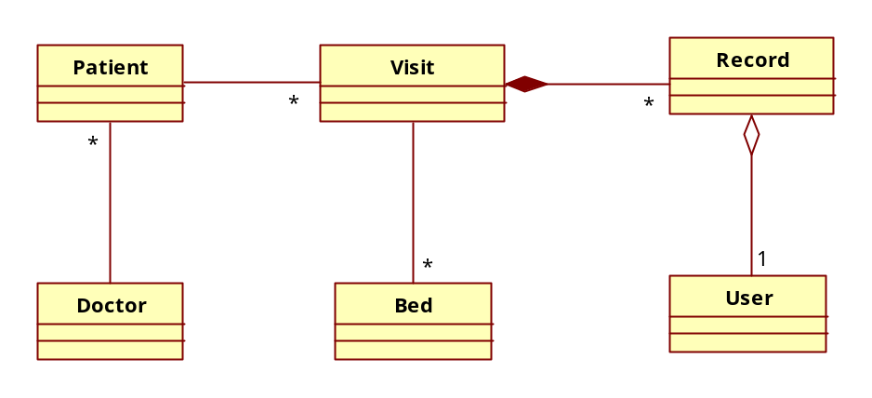

Patient Record Model

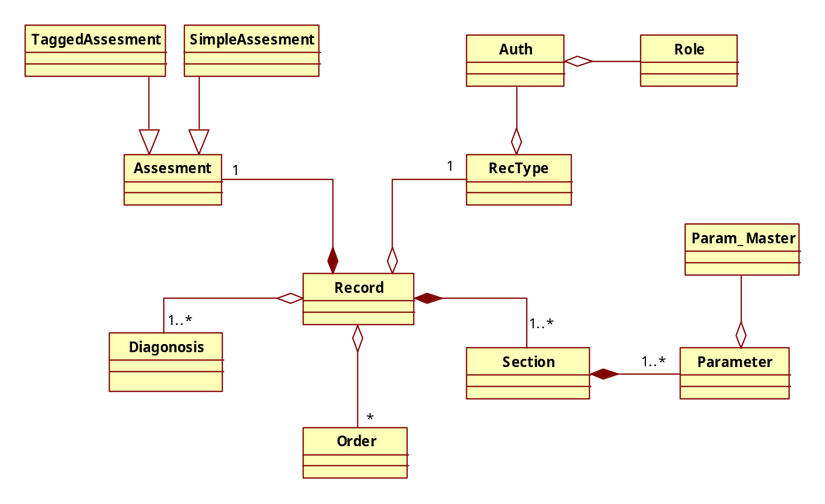

Order Model
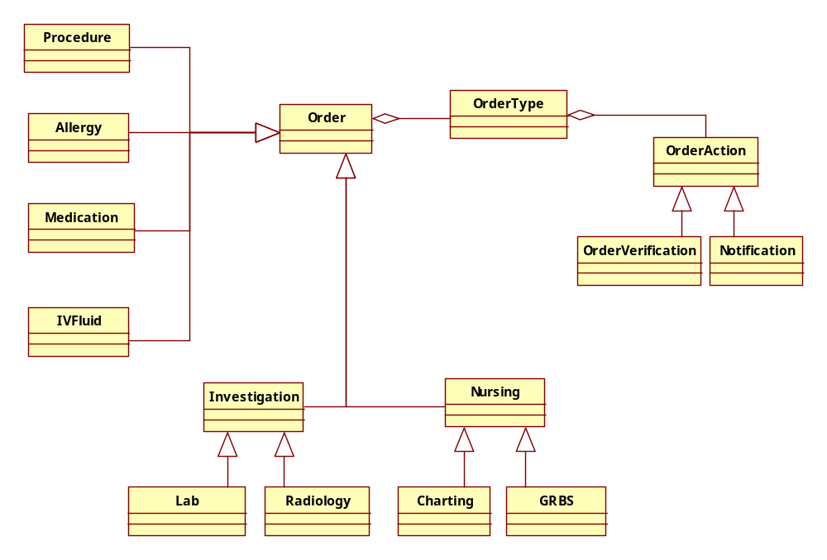

Size and Performance
TODO

Hardware requirement
Application Server | JBOSS Application Server  Processor: Intel Core2 Duo  Memory : 4 GB to 8GB  HDD : 180 to 250 GB
Database Server | MySQL Server  Processor: Intel Core2 Duo  Memory : 4 GB to 8GB  HDD : 180 to 250 GB
SMS Server
Index Server | DBSight
TabletPC
e-Pen

Software Requirement
Technology in Use | GWT 2.0 (Presentation Layer)  Java/J2EE – Core Business Process and Service implementation
Database | MySQL
Reporting Tool | Business Intelligence
Development IDE | Eclipse Galileo
Version Control | CVS
Automation Build | Cruise Control
Browse Support | IE 7+, Mozilla 3.5+, Safar 4.0+

